Ideation Phase
Brainstorm & Idea Prioritization Template

Date | 28 June 2026
Team ID
Project Name | India's Agricultural Crop Production Analysis
Maximum Marks | 4 Marks

Brainstorm & Idea Prioritization:
Problem:
Agricultural data is difficult to analyze due to its large size and complexity.
Idea:
Develop an Agricultural Crop Production Dashboard using Tableau.
Why this idea?
- Easy to understand through visualizations.
- Helps analyze crop production by state, district, season, and crop.
- Supports better decision-making using data.

Step-1: Team Gathering, Collaboration and Select the Problem Statement
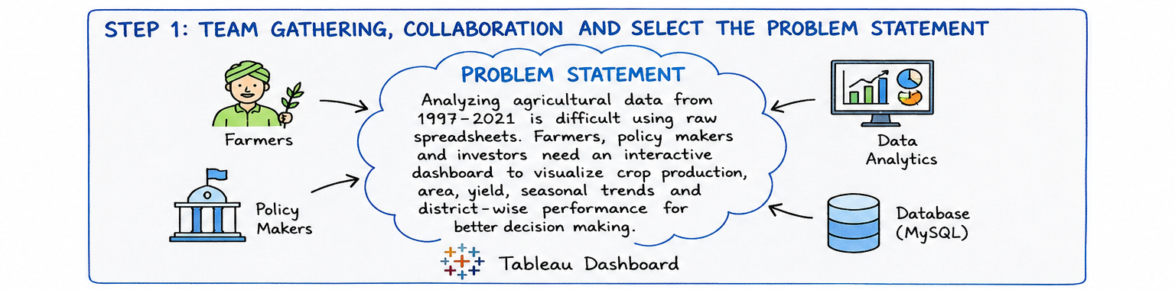

Step-2: Brainstorm, Idea Listing and Grouping
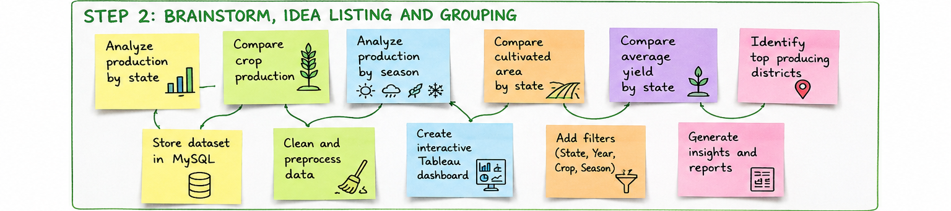

Step-3: Idea Prioritization
